My initial thought for the project is to design a server room. A large group of networked computer servers typically used by organizations for the remote storage, processing, or distribution of large amounts of data. Data and information are Stored, Managed and Processed. Data center provides concise monitoring of Secure Activity, Network Performance and Web traffic. A green data center, or sustainable data center, is a server facility which utilizes energy-efficient technologies. They do not contain obsolete systems (such as inactive or underused servers), and take advantage of newer, more efficient technologies. Requirements for a properly functioning Data center are: Air conditioning, Expenses, Data protection, Fire protection, Sustainability (energy costs), Qualified Staffs, Security, A Technological Infrastructure
In this class I have learnt different stages of designing and methods in designing. Especially more in the software of CATIA. But in my project, I have used Solidworks for my project. I have thought of designing Data center room. In our Campus I usually use Gauss Engineering lab a lot. I thought of utilizing those same space or area for data center in the Gauss Engineering lab. There are many benefits of having Data center. Moreover, we should also design a sustainable data center. Due to data center there are lot of heat emissions and affecting the environment a lot due to the emissions into the atmosphere. There are certain benefits of designing a sustainable data center. Some of them are: Superior power capacity and consumption management using real data, not plate values. Easily document effectiveness of “green” initiatives. Provides dynamic feedback loop for automating climate control systems. Reduces unplanned downtime for equipment failures based on power issues. So I have decided to design a Sustainable data center for the lab. With the help of HVAC unit for the Sustainable data center.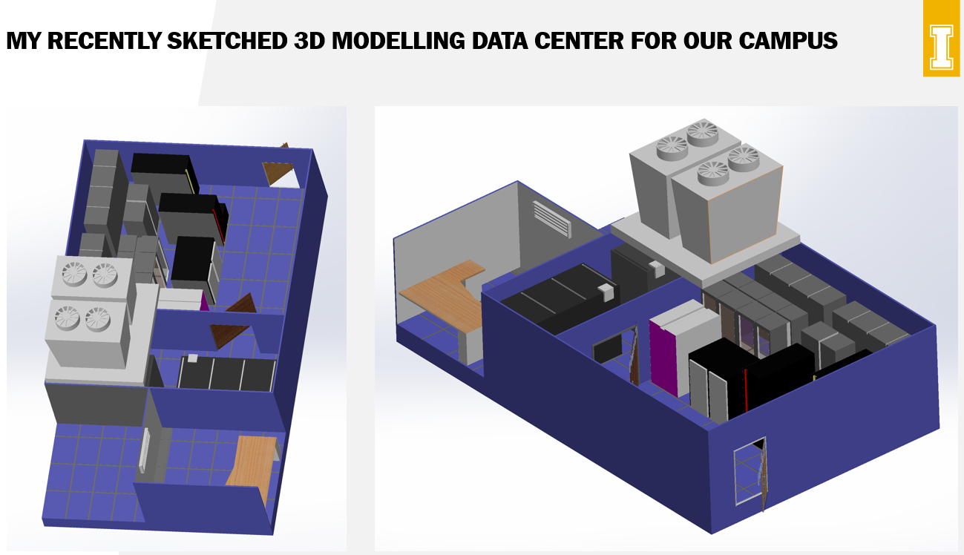

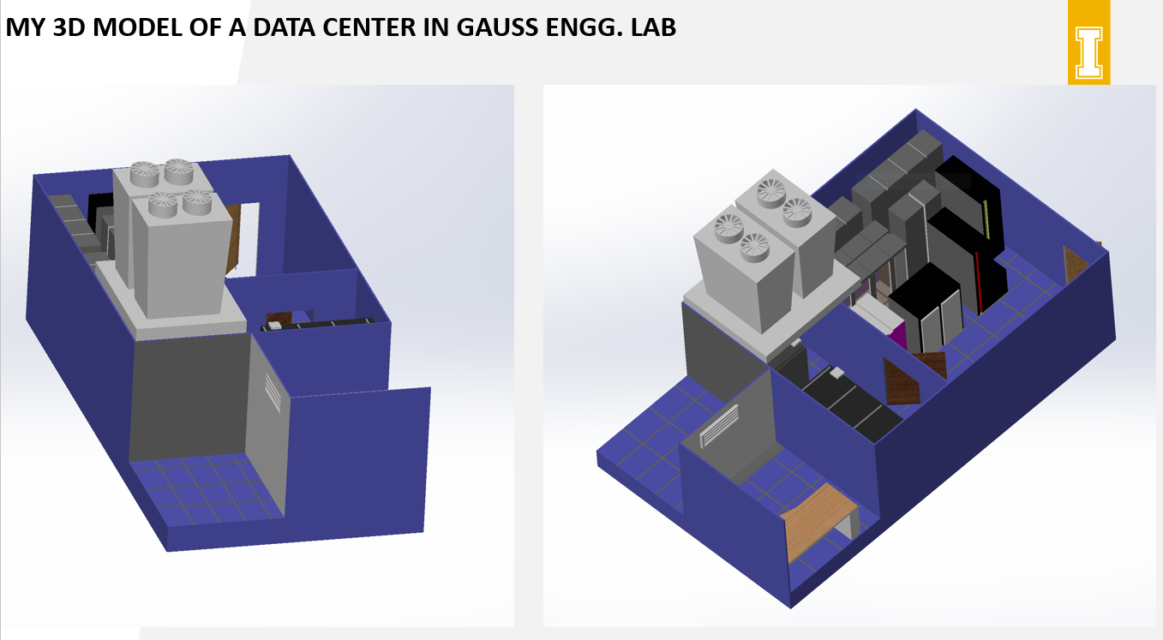
I have used this idea for designing from one of the google sources. Here I have designed the room in such a way that I have given more weightage for data center aspect. Where the servers are given much more space and compatibility. I have taken entire room in our Gauss engineering building for my reference to sketch the sustainable Data Center for our University. These were based on the Gauss Engineering 115 computer science lab. There will be some exact fitting or not so correctly fitting data center. I have used most of the space for the Server room. I have given some free space in order to use as a Restroom for the person who maintains the Server room. I have also given a provision room with a table for the person who maintains the server room. So, these are the spaces filled except the server room. I didn’t mention as a restroom, but it is a free space which is left and can be used for various purposes. I am giving just an idea that it can be used for a small restroom if required. Coming on to the server room. I have given a main door for the server room which can be used as the main entrance. I have split the server room as two parts where the bulk of the main servers will fall under a major part whereas we can use the secondary room where it comes with another door as an entrance to get in. The bulk of the major server racks will be in the major part of the room and the secondary servers will be in the small room where only few server racks are stacked. The air conditioning unit is in the form of HVAC unit which is placed on the top of the entire room. As seen in the picture I have designed a HVAC unit on top of the server room alone. It will not be projected on to the extra projected rooms. This is the room plan of my designed Server rooms. I have learned to design a 3D modelling software and in this course I was able to design different components, assembly of different sub parts into a major finished product, Design tables for various different criteria and finally designing a data center with help of a 3D modelling software.

